# Clustering Gentrification: Neighborhood Change in Nashville, TN.

David Knorr, M.S., Jonathan Gilligan, Ph.D.

9/30/2021

Keywords: Gentrification, Neighborhood Change, Machine Learning, Unsupervised Learning, Clustering

## Abstract

Gentrification is a polarizing and quantitatively elusive type of neighborhood change that disproportionately threatens to displace our community’s most vulnerable populations. Here we examine the shortcomings of threshold-based research methods used to identify gentrification and advance a more objective k-means clustering alternative. We highlight major methodological inconsistencies in legacy models which misconstrue gentrification’s costs, benefits, and causes. Our clustering method uses six census change variables to identify five dominant trajectories of neighborhood change in Nashville, TN (Davidson County) between 2000 and 2019. Two emergent typologies exhibit patterns of gentrification, restructuring, and potential residential displacement. Gentrification typologies are juxtaposed by a typology emblematic of low-income resettlement along suburban highway corridors. A significant join-count statistic reveals that Nashville neighborhood change is spatially clustered (i.e. non-random), suggesting a structured process that may benefit from forward-looking and predictive research.

# Introduction

Since Glass (1964) first described gentrification as “working class quarters invaded by the middle class,” the process has been the subject of rich academic focus and policy debate. Over time researchers have struggled to clearly identify and characterize which kinds of neighborhood restructuring constitute gentrification. The meaning of gentrification has expanded to encompass many kinds of change, diluting its value as a clear organizing concept for analyzing neighborhood change.

Maloutas (2012a) argues that the conceptual definition of gentrification has been stretched unrecognizably since its infancy and original context, resulting in “a regression in conceptual clarity and hence in theoretical rigor.” This loss of focus in discourse has leaked into research where it has inhibited efforts to calculate the benefits, costs, causes, and responses to gentrification. The loose conceptual foundations of gentrification have licensed a spectrum of quantitative methods to identify the process and to stake competing claims as fact.

There is no shortage of definitions offered for gentrification by social scientists, economists, urban researchers, and geographers. Many focus on displacement of vulnerable (older, lower-income, less-educated, and minoritized) residents by highly privileged ones (younger, higher-income, more educated, and predominantly white) (Marcuse 1985, Elliott-Cooper et al. 2020), whereas others focus more on place than on people, and define gentrification to include the transformation of vacant land to residential or commercial use that targets affluent professionals (Zuk et al. 2015, Slater 2000). Operational definitions are similarly diverse, and this diversity makes it difficult to achieve consensus in identifying which neighborhoods are gentrifying, as opposed to those undergoing different kinds of change (Barton 2016). Within public discourse, the gentrification debate is shaped by the unique experiences of individuals and the threats or perceived benefits of the process. The many depictions gentrification in both research literature and public discourse reflects the richness of the subject, but also adds confusion to expert and lay discussions when speakers using different conceptions and definitions can talk past one another.

We propose that quantitative definitions of gentrification, based on empirical data about neighborhood change, may add clarity and consistency to research and the application of research to informing policy and planning while also allowing enough flexibility to reflect the different characteristics that gentrification exhibits in different cities. This paper presents a new data-driven approach to operationally defining, identifying, and measuring gentrification.

The displacement of vulnerable residents by powerful and privileged ones, and associated conflict between longtime residents and newcomers, are central to many definitions of gentrification (Slater xxxx, Marcuse xxxx.) Atkinson (2004) states ”... the term gentrification is predicated on displacement and community conflict.” However, other researchers (Freeman and Braconi 2004; Vigdor 2002, Hamnet 2009) avoid the distinction that gentrification is predicated on displacement. From this perspective, a crucial question is, “does gentrification cause displacement?” In this paper, we take displacement as an essential characteristic of gentrification and one that plays an important role in differentiating gentrification from other types of change. We understand gentrification as an evolving spatial and temporal process associated with the movement of both people and capital, that entails a sustained period of disinvestment, followed by an influx of investment and wealthier residents that results in the displacement of existing residents.

Figure 1 illustrates the process of differentiating gentrification from revitalization. Both kinds of neighborhood change entail investment and improvements to amenities, infrastructure, and homes; however, revitalization benefits existing residents, draws upon their capacity to stay, and is considered desirable by many communities and city-planners. Thus, we refer to gentrification without displacement simply as revitalization, in order to avoid confusion around the theoretical quandaries over the role of displacement in gentrification (Clay, 1979; Zuk et al., 2015). Others express similar views: Halle and Tiso (2014) propose that gentrification is used “*very loosely, conflating several issues that should be considered separately.*” Stern and Seifert (2007) contend that “..*if we see neighborhood revitalization as desirable, we cannot afford to label all population change as gentrification*.”

*Figure 1. Conceptual Diagram Distinguishing Gentrification Apart from Revitalization*

Our conceptual framework for gentrification answers Lees’s (2007) call for a “*more fine grained approach in gentrification research, one that is both more specific and more general*”.[1] The conceptual definition advanced here is more specific by requiring the displacement of existing residents, and more general, in that it attributes the social and cultural changes to a broad class of measurable patterns in demographic and economic change. Displacement presents specific challenges to data collection and analysis, but population flows, stratified by race, income levels, and educational attainment, can serve as useful proxies. Likewise, investments and disinvestments are more directly captured in home/rent values, human capital (education), public amenities, businesses, and various other socioeconomic variables.

Drawing upon this theoretical background, we develop a data-driven approach to identifying gentrification, which maintains conceptual coherence with a focus on displacement of minoritized and other socio-economically vulnerable groups by white, affluent, highly-educated ones. This approach balances the conceptual specificity lacking from prior efforts to identify gentrification with the quantitative flexibility to identify gentrification apart from other types of neighborhood change within a defined time and place.

## Quantifying Gentrification

The quantitative methods used to identify gentrification apart from other neighborhood change trajectories have, at best, failed to reach any form of consensus, and at worst been used as self-serving tools to crystalize competing worldviews. Gentrification research bypassed initial red flags when translating Glass’ observations to a measurable process. An early warning by Galster and Peacock (1986) stated:

“*If one wants to better understand, predict and even alter changes in urban neighborhoods, one thus must be exceedingly careful in operationally specifying the exact dynamic in question, and must recognize that such a specification may, in itself, influence the outcome of the analysis.*”

The same study’s sensitivity analysis on Philadelphia census tracts concluded, *“unambiguously that how one defines gentrification crucially affects which and how many tracts are identified as having undergone gentrification”* (Galster and Peacock 1986). The study showed that strict criteria could limit the number of eligible census tracts labeled as gentrified to as little as 6%, while less stringent criteria could identify up to 82% of tracts as gentrified.

Despite these cautions, modern research exercises varying, but equally arbitrary, operational definitions of gentrification. Until the last decade, such methodological discrepancies received little attention apart from a few skeptical researchers. Among these, Maloutas (2012) noted that researchers “*would have plenty to gain from an increased awareness of the contextual limits of their own tools.*” Similarly, Brown-Saracino (2017) suggest that the spectrum of operational definitions “*gesture to collective uncertainty about how to define and operationalize gentrification*.” Easton et al. (2019) provide the most detailed critique of quantitative methods to identify gentrification and displacement but stop short of defending an alternative. The following section critically examines the inconsistencies and limitations of the primary class of methods used to identify gentrification in practice.

### Threshold Strategies

Quantitative studies attempting to identify gentrification generally take the form of a two-tiered, threshold framework in which spatial units are qualified as eligible for gentrification during a starting year based on one or more socio-economic thresholds (Figure 2). This eligibility step explicitly limits gentrification to lower socio-economic areas and may also include explicit spatial restrictions to limit gentrification to inner-city tracts. In practice, eligibility constraints vary considerably and act as subjective levers governing the scope of areas considered for gentrification. Countless threshold-variable combinations have been used to dictate eligibility including Hammel and Wyly’s (1996) definition that requires eligible census tracts to begin the time period below city-wide median income. Elsewhere, Ellen and Ding (2016) require eligible tracts to be located within the central city and have average family incomes below the 40th percentile of metropolitan-wide average family incomes. Another example, Maciag (2015), restricts gentrification to the bottom 40th percentile of both median household income and median home value compared to all tracts within the metropolitan area. Given the benefit of the doubt, eligibility constraints may parallel the objectives of Bayesian prior distributions. However, these constraints are too often purely speculative and statistically unfounded, instead relying on a subjective belief that gentrification may only begin at some arbitrarily-imposed initial socioeconomic status.

Figure 2. General threshold framework used to identify gentrification.

Areas satisfying eligibility criteria are considered “gentrified” by outpacing one or more socioeconomic variables. Hammel and Wyly’s (1996) method identifies gentrification by eligible tracts that rise above city-wide median incomes in the subsequent decade. Ellen and Ding (2016) require a minimum 10 percentage point increase in the tract-to-metro ratio of average family income, percentage of white residents, percentage of college-educated residents, or median rent. Maciag (2015) requires gentrifying areas to experience increases in both college attainment and inflation-adjusted median home values in the top third percentile of all metro Census tracts.

Varying time periods, proxy variables, study areas, spatial units, and data sources can be found across neighborhood change literature. Geographic scales and contextual differences may be easily overlooked across studies (Lees, 2000). National-scale studies are often limited to high-level census data, which can mask important inter-city variabilities. Whereas individual city studies tapping local-level data may have incomparable demographics, policies, paces, and other external factors that limit generalization to other cities. Finally, as gentrification progresses, many displacement studies of the early millennium no longer represent current market conditions, consumer sentiment, or changing housing polices.

The shortcomings of threshold methods extend beyond simple inconsistency and instability. As we will show, these methods are susceptible to confirmation bias by assuming *a priori* that gentrification is a significant neighborhood-shaping process within a specified city and time. Such expectations are computationally fulfilled by comparing tract changes to city-wide medians or averages, which invariably label areas as gentrifying, regardless of time period or city[2]. The method’s use of relative thresholds ensure its own success by conforming the process to its predetermined framework. Finally, additional social, economic, and built environment variables are incompatible with threshold methods because adding more threshold criteria guarantees that fewer and fewer areas will be considered gentrified, unless threshold values are simultaneously broadened.

#### Threshold sensitivity

Given the various methods used to identify gentrification, we highlight the results produced by three seminal gentrification studies: Freeman (2005), Ellen and O’Regan (2010), and McKinnish et al. (2010)[3]. Enterprise Community Partners (2019) online Gentrification Comparison Tool (GCT) allows users to compare the three methodologies used to identify gentrification across 93 cities and four 10-year periods.

Each method uses a different eligibility precondition: the 50th percentile of metro-wide *median* household income, 70th percentile metro-wide *average* household income, and the 20th percentile nation-wide *average* family income. Freeman’s (2005) median household income threshold contains notably admits that “*the median is an admittedly arbitrary threshold.”[4]*

Table 1. Eligibility and gentrification criteria as applied by Freeman (2005), Ellen and O'Regan (2010), and McKinnish et al. (2010).

|  |  |  |  |
| --- | --- | --- | --- |
|  | **Freeman** | **Ellen and O'Regan** | **McKinnish et al.** |
| **Eligible** | Median household income **and** percentage of housing built in prior 20 years both less than metro-wide values in 2000 | Less than 70% of metropolitan average household income in 2000 | Average family income in bottom 20% of nationwide urban tracts in 2000 |
| **Gentrified** | Eligible **and** change in residents with college degree greater than metro-wide average **and** increase in real housing prices between 2000 and 2010 | Eligible **and** minimum of 10 percentage point increase in the ratio of tract-to-metro average houshold income between 2000 and 2010 | Eligible **and** real increase in average family income of at least $10,000 between 2000 and 2010 |

The methodological differences are compounded by each definition’s gentrification change condition. The Ellen and O’Regan and McKinnish et al. definitions both use (different) income measurements (household vs. family) to signal gentrification, as well as differing threshold types (relative for Ellen and O’Regan and absolute for McKinnish et al.). Freeman, however, only considers the cardinality of housing prices in addition to the relative gain in college-educated residents as a proxy for socio-economic upgrading.

Figure 2 displays the mapped results of eligible and final gentrification classifications in Davidson County, (Nashville, TN) between 2000 and 2010. Freeman’s definition yields the most inclusive classification of the three approaches, labeling 37 Census tracts as gentrified, followed by Ellen and O’Regan and McKinnish et al. which identified 8 and 5 gentrified tracts, respectively. Only three census tracts in Davidson County were consistently identified as gentrified across all three definitions.

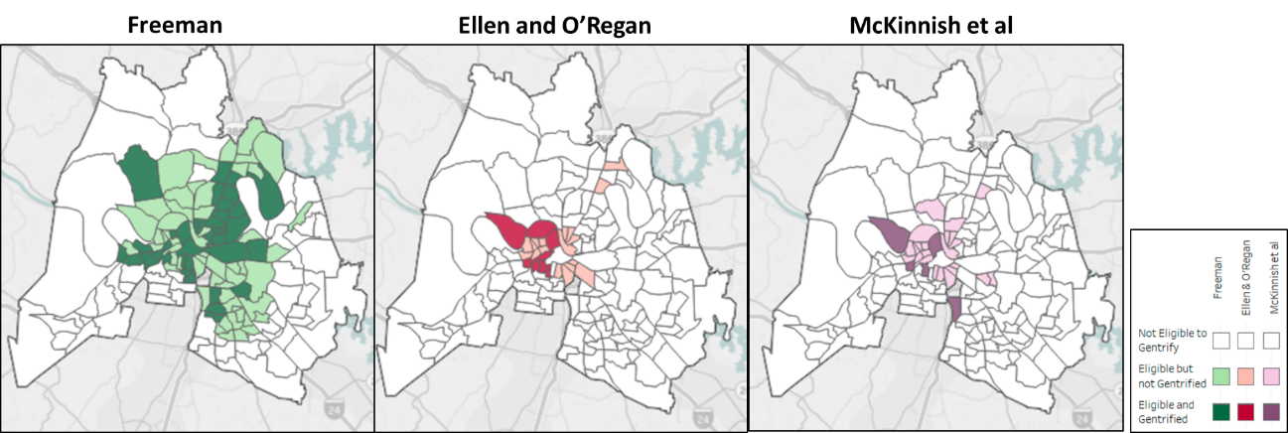

Figure 2. Variability in areas identified as gentrified within Davidson County, Tennessee (2000 - 2010).

The inconsistent performance is not unique to Nashville; the inter-definitional disagreement grows when extrapolated across the 93 cities considered in the GCT tool. Freeman’s definition identified 3,221 Census tracts as gentrified between 2000 and 2010 compared to 782 for Ellen and O’Regan and 501 for McKinnish et al. Out of 3,787 total “gentrified” census tracts, only 152 tracts, or 4%, were identified by all three methods (Drew, 2019).

### Consequences

The identification or labeling of gentrification is often only the first step for studies attempting to investigate the extents, costs, benefits, or causes of the process. Substantial research has focused on characterizing the demographics of gentrifiers, displacement rates, crime, education, health, and economic outcomes of gentrification (Source). These studies share a common need to operationalize a definition of gentrification to differentiate gentrified areas apart from non-gentrified or control areas. These studies most commonly adapt a version of the threshold methods discussed in the previous section. In doing so, these methods often include the poorest populations within “reference” or non-gentrifying locations, creating an artificially vulnerable sample to compare against.

Unsurprisingly, these studies have produced a trove of contradictory results regarding the costs and benefits of the process. These mixed results have armed both supporters and opponents of gentrification with quantitative evidence to further entrench their views. The provocative conclusions of the three cited methods above were used to mitigate the external threats of gentrification on vulnerable residents via public media. Ellen and Gould conclude, “*original residents are much less harmed than is typically assumed. They do not appear to be displaced in the course of change, they experience modest gains in income during the process, and they are more satisfied with their neighborhoods in the wake of the change.*” The conclusions of the other two studies were foundational to news articles titled “*Gentrification: Not Ousting the Poor?”* (Kiviat, 2008) and “*Gentrification is a Boost to Everyone*” (Hampson, 2005).

Many residents, specifically renters, lack the financial or social ability to keep pace with the stressors introduced by gentrification. Therefore, it is important to highlight that those displaced early in the gentrification process may be unable to realize *any* of its reputed benefits. The obfuscated public sentiment surrounding the problem of gentrification is divided squarely along the unequal distribution of its costs and benefits. The costs of gentrification are disproportionately placed onto our communities’ most vulnerable populations; groups that have that have borne centuries worth of compounding costs manifested in slavery, segregation, systemic racism, and discrimination. In this light, gentrification is fundamentally ill-suited for analyses of net effects, especially when the methods used to identify the process hinge on such an “*admittedly arbitrary threshold*” (Freeman, 2005).

~~The loose conceptual definition of gentrification has afforded brittle operational methods to identify the process. Their sensitivities and subjectivities produce a dependent/independant variable that resists generalizations of cause or consequence. Instead, an arbitrary and limited set of criteria is mistranslated to the process termed gentrification only in name. This paper identifies and supplements the shortcomings of threshold methods, advancing a more holistic quantitative method to identify gentrification within the broader context of neighborhood change.~~

### Clustering Strategies

The limitations of legacy methods to identify gentrification spawned a more recent class of models to identify the process. Clustering is an unsupervised machine learning technique that can be used to group observations based on patterns of multiple input variables. In the context of neighborhood change, it can be used to distinguish the dominant trajectories that neighborhoods change over time. This method reconciles Brown and Saracino’s (2017) call “*to study the city more holistically, capturing neighborhood change and stasis, poverty, affluence, and everything in between*”, as well as Clark’s (2005) petition for an “*elastic yet targeted definition of gentrification.*”

Clustering techniques bypass many of the limitations and biases of threshold methods. This method categorizes observations (census tracts) into clusters, or groupings that exhibit similar patterns and characteristics from measured data, rather than a predetermined framework. The method captures the multi-dimensionality of neighborhood change by incorporating multiple input variables, while avoiding *a priori* confirmation biases by making no guarantee that gentrification, nor any other predetermined neighborhood change type, will be identified. Instead, this approach naively reframes the question from “*Where is gentrification happening?”* to “*What are the dominant pathways that neighborhoods change over time?*” Whereas classical methods conform gentrification to an artificial set of pre-defined thresholds, their clustering counterparts identify the dominant trajectories that neighborhoods *can* change.

Boddy (2007) correctly identifies that “*an unsupervised classification algorithm cannot tell which combination of variables is necessary and/or sufficient to define gentrification*.” Rather, this approach necessitates a thorough *post hoc* examination of cluster outcomes. Subjectivity, biases, and heuristics must be acknowledged and mitigated at this step by building data-driven interpretations based on relative and absolute statistics as well as spatial organizations. This shifts the researchers burden of subjectivity from pre-analysis to post-analysis and from injunction to interpretation based on reportable results. The output is a robust classification framework that may be used for more precise cross-city comparisons or as a variable for effect-size, cost/benefit, or other derivative gentrification research.

Different versions of clustering frameworks have been applied within the context of neighborhood change. Podagrosi et al. (2011) used k-means clustering to distinguish typologies of neighborhood change in Houston between 1980 and 2000. The study used principal component analysis (PCA) to preprocess thirty-eight change variables down to five dimensions of change. 54 Census tracts showed levels of upgrading in line with their definition of gentrification. Across these tracts, college graduates increased by 88%, home values increased by 30%, and per capita incomes increased by 53.1%. Ling and Delmelle (2016) preprocessed 11 Census change variables (1970 -2010) using a self-organizing map procedure before conducting a k-means clustering analysis to analyze temporal trajectories in eight US cities.

Liu et al (2019) compare a k-means clustering approach against a threshold method in Auckland, Australia. They conclude that “*both approaches are in accord with each other*” and advocate that the methods be used in conjunction. However, the conclusions of this work are less generalizable as the compared methods are inter-dependent. The study iteratively adjusts threshold values to maximize the similarity to that of the clustering method. That is to say, the two methods *can* produce similar results only after a mathematical search of optimized threshold values. In practice, the intra-sensitivity within a single threshold definition can obscure its comparison to a clustering approach.

A warranted criticism of clustering methods asserts that what they gain in objectivity is sacrificed in interpretability. This issue is addressed here by applying intuitive summary statistical deconstructions of original data. In addition to summary change statistics, starting/ending magnitudes and spatial distributions guide the translation from raw cluster outputs to labeled neighborhood typologies. Previous methods applying machine learning to neighborhood change fall short of distilling the “*know-it-when-you-see-it*” fingerprint of gentrification with objective, quantitative, yet understandable reporting metrics. With this tension in mind, we aim to balance the objectivity of machine learning methods, with the recognizable patterns of gentrification and other types of neighborhood change.

## Case Study

The 2019 Nashville metro area population totaled over 670,000 people, representing the 24th largest incorporated city in the United States (U.S. Census Bureau 2019). Nashville has experienced a rapid population growth and pervasive concerns of gentrification (Haruch, 2014; Larsson, 2017; Plazas, 2017). The hazards of gentrification are chronicled by David Plazas (2017) in the Tennessean newspaper series titled “*Costs of Growth and Change in Nashville.*” Many of Nashville’s longtime citizens describe financial pressures amid rising rent and property tax values as well as social isolation as neighborhoods are redeveloped for a more expensive clientele. Plazas identified the inequality and community concerns amid Nashville’s growth, writing “*African Americans have been hit exponentially hard in Nashville.*” He also cites the changing socio-economic geography amid gentrification: “*The segregated areas where* [African Americans] *once lived around the urban core, like East Nashville, Germantown, and Edgehill, have now become high-rent, whiter communities*” (Plazas, 2017). It is within these contexts that we apply our clustering framework to fingerprint the dominant types of neighborhood change in Nashville, Tennessee.

While this analysis is specific to Nashville, its methodology accommodates the changing faces and stages of neighborhood change in different cities. As Shaw (2005) notes, gentrification “*plays out differently in different places and the process is deeply affected by the local context.*” Accordingly, we expect neighborhood change in Nashville, New York, San Francisco, and Atlanta to display different characteristics, advance at different paces, and reveal different spatial extents. The clustering method advanced here affords these contextual differences while allowing for the cross-comparison of different city’s neighborhood change fingerprints. This transparent, city-specific, and quantitative definition for gentrification avoids many of the biases associated with the threshold frameworks used to identify gentrification.

# Methods

Our clustering methodology uses six U.S. Census variables to capture fundamental aspects of neighborhood change: rent value, home value[5], income, race, educational attainment, and percentage of multi-unit buildings (Table 2). The proportion of multi-unit dwellings, as well as home and rent values describe investment and disinvestment patterns within the built environment. Income, race, and educational attainment changes are included to signal changes to residents. While income and education levels may increase without displacement, race is necessary to differentiate incumbent upgrading from ethnic displacement, the primary negative externality of gentrification. These six variables are calculated as percent change between 2000 and 2019. As such, we are concerned with the relative evolution of neighborhood change, irrespective of starting socio-economic or demographic compositions.

Table 2. Features included in k-means clustering analysis (calculated as percent change 2000-2019).

|  |
| --- |
| Clustering Variables |
| Median Home Value |
| Median Rent Value |
| Median Household Income |
| Percentage of Persons 25+ with College Degree |
| Percent Non-White |
| Percent Multi-Unit Housing |

Previous researchers employing k-means methods have used a larger number of variables to identify neighborhood change trajectories (Delmelle, 2016; Podagrosi et al., 2011). To accommodate these variables, PCA is used to reduce the dimensionality to a handful of information-dense variables. While PCA can accommodate larger feature spaces, it can verge on theoretical overfitting of gentrification signals, while also sacrificing interpretability and potentially washing out the most direct measurements of investment, disinvestment, and demographic turnover. Instead, we cluster on six most direct proxies for investment change. The six features listed in Table 2 balance more dimensions than threshold methods, but fewer features than previous clustering methods. This approach bypasses the need for dimensionality reduction and allows for more direct and intuitive reporting without diluting the direct and intuitive change factors (Rheades 2019).

Five Davidson County census tracts were excluded from the cluster analysis based on the absence of residential land use; these tracts are entirely composed of commercial, industrial, and/or academic areas. Median rent values (2019) for two census tracts (47037016500 and 47037018203) were imputed from an average of adjacent median rent values. This imputation did not affect the conclusions of clustering typologies or spatial statistics.

## K-Means Clustering

K-means clustering is a type of unsupervised machine learning technique that partitions observations into K numbers of user-specified groupings. The k-means objective function iteratively assigns observations to a cluster that satisfies the minimum within-cluster sum of squares (MacQueen, 1967). The proceeding step calculates and adjusts the new means to the centroids of the new cluster. K-means can be sensitive to the starting location of cluster centroids (Yi et al., 2010).[6]

The selection of the optimal number of clusters in the dataset is a critical decision in cluster analysis that is specific to the problem context (Sugar and James, 2003). We considered direct methods of total within-cluster sums of squares (WSS) and average silhouette scores to guide our selection of the optimal number of clusters. WSS can be thought of as a measure of compactness, with the objective that the selected number of clusters minimizes intra-cluster variation. Additionally, we validate the choice of K (number of clusters) via the silhouette method, which compares a record’s similarity (Euclidian distance) to its own cluster against other clusters. K = 2 maximized average silhouette widths but implies a binary classification of neighborhood change that does not fit our objective to classify multiple cluster trajectories. Figure 4 displays the cluster compactness within the feature space of the first two principal components at varying cluster sizes (K).

Five clusters were ultimately chosen to balance performance and the distinguishable patterns associated of neighborhood change. The selection of 5 clusters is also consistent with prior neighborhood change studies such as Owens et al. who use 5-7 clusters. Because cluster size selection is susceptible to some degree of subjectivity, we mapped the results at varying cluster size specifications (Figure 9). These results exemplify the robustness of a distinct gentrification typology irrespective of the cluster size specification.

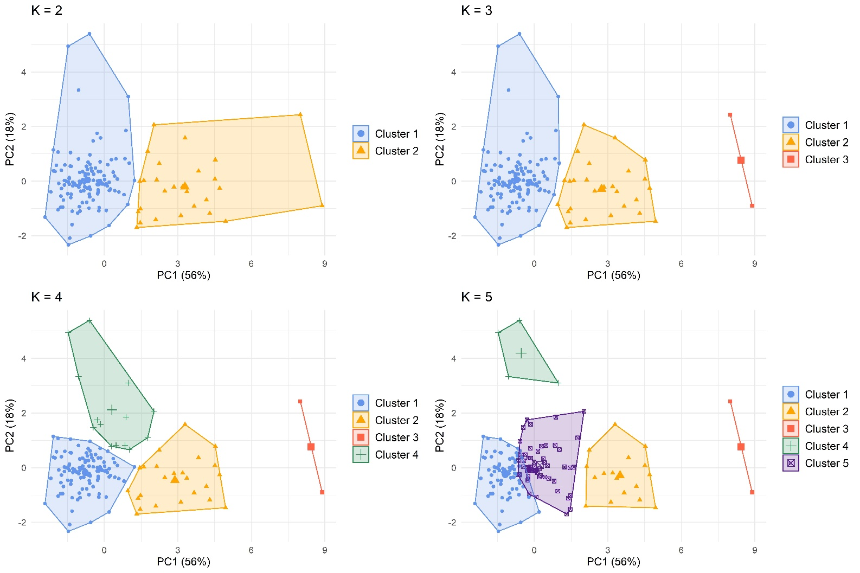

Figure 3. Cluster geometries based on cluster size specifications. Plotted against the first two principal components (74% of total data variance).

## K-Color Join Count Statistic

The spatial independence of the five categorical neighborhood change typologies was evaluated using the K-color join count statistic (Dacey, 1968). This statistical test considers a null hypothesis that the observed distribution of observations is random. 10,000 Monte Carlo permutations were performed using the “joincount.mc” function in the “spded” R package (Bivand, 2019).

Spatial contiguity was formally defined using both first and second-order queen’s case[7] adjacency matrices. First-order queen’s case classifies spatial neighbors that share either a common edge or common vertex, while the second-order matrix extends the neighbor relationship to include tracts that share an edge or vertex with first-order neighbors (neighbors of neighbors). Figure 5 maps the first and second-order adjacency matrices for census tracts in Davidson County. First-order contiguity is a more localized measurement of adjacent neighbors with an average of 6 neighbors per census tract, while second order contiguity averaged 18 spatial neighbors. For sensitivity, we also examined rook’s case contiguity (requiring a shared edge); First-order rook’s case contiguity resulted in an average 5.07 links and did not affect our overall interpretation of spatial autocorrelation.

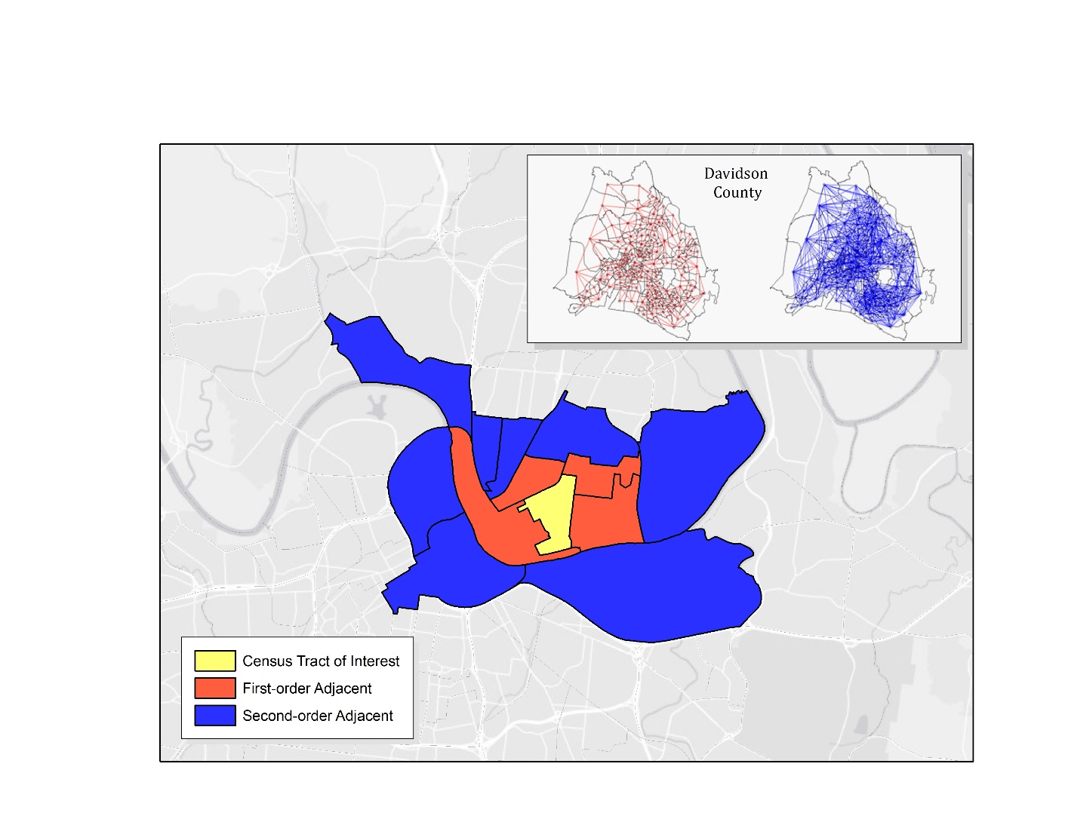

Figure 4. Comparison of first and second-order queen's adjacency matrix and sample census tract. The inset map on the top of the figure displays the first (red) and second-order (blue) spatial relationships of all Davidson County census tracts.

# Results and Discussion

We investigated neighborhood change in Davidson County, TN via k-means clustering of the percent change of six census change variables between 2000 and 2019. The output of the clustering method is then translated to recognizable neighborhood change typologies. This step invariably introduces the potential to leak subjective beliefs and/or expectations. Therefore, interpretations follow the spatial distribution of clusters, percent change statistics, and starting/ending absolute values. Typologies are only then contextualized by local domain knowledge of neighborhood change advanced and compared against current or future ground-truthed obervations. Table 3 provides the context of Davidson County-wide change summary statistics. These system-wide trends include an increase in both home and rent values by 28 and 20 percent, respectively. Inflation-adjusted household income increased by less than one percent, while multi-unit housing fell by less than one percent. College attainment jumped nine percent and proportion of white residents fell by over four percent across Davidson County.

*Table 3. Davidson County summary statistics*

|  |  |  |  |  |  |  |  |
| --- | --- | --- | --- | --- | --- | --- | --- |
| **Davidson County (n=156)** | **2000** | **2019** |  | **Percent Change** | | | |
| *Median* | *Median* |  | *Mean* | *Min.* | *Median* | *Max.* |
|  |  |  |  |  |  |  |  |
| Median Home Value | $158,068 | $211,900 |  | +53% | --23% | +29% | +310% |
| Median Rent Value | $59,040 | $58,830 |  | +29% | --41% | +20% | +306% |
| Median Household Income | $929 | $1,095 |  | +9% | --51% | +0% | +272% |
| Percent College Degree | 24% | 35% |  | +11% | --11% | +9% | +59% |
| Percent Multi-Unit Housing | 38% | 34% |  | --1% | --66% | --1% | +32% |
| Percent White | 75% | 68% |  | --3% | --42% | --4% | +60% |

Figure 5. Map of Davidson County cluster outcomes (2000 – 2019)

Figure 8 displays the results of the five neighborhood change clusters within Davidson County.

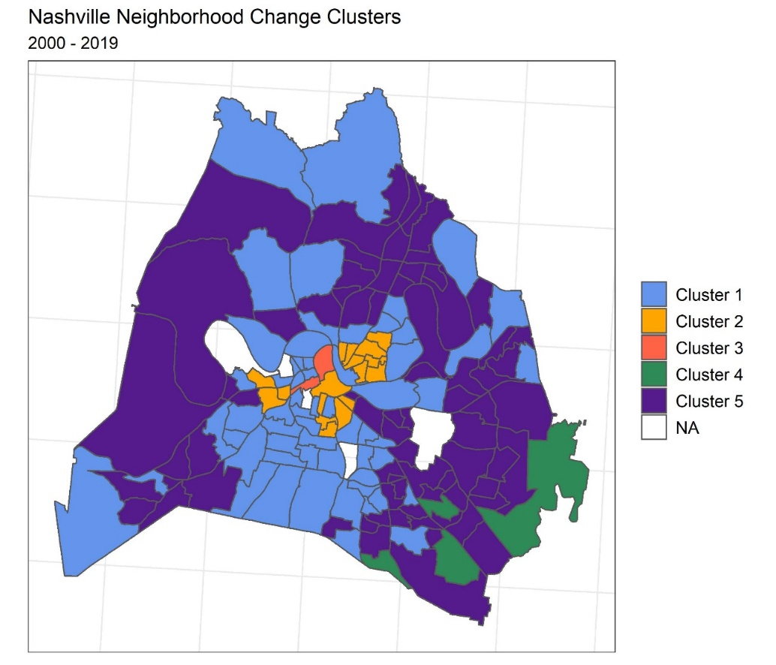

*Figure 8. Davidson County normalized neighborhood change typologies. “NA” tracts are entirely non-residential areas.*

*Figure 9. Nashville cluster groups starting (2000) and ending (2019) values*

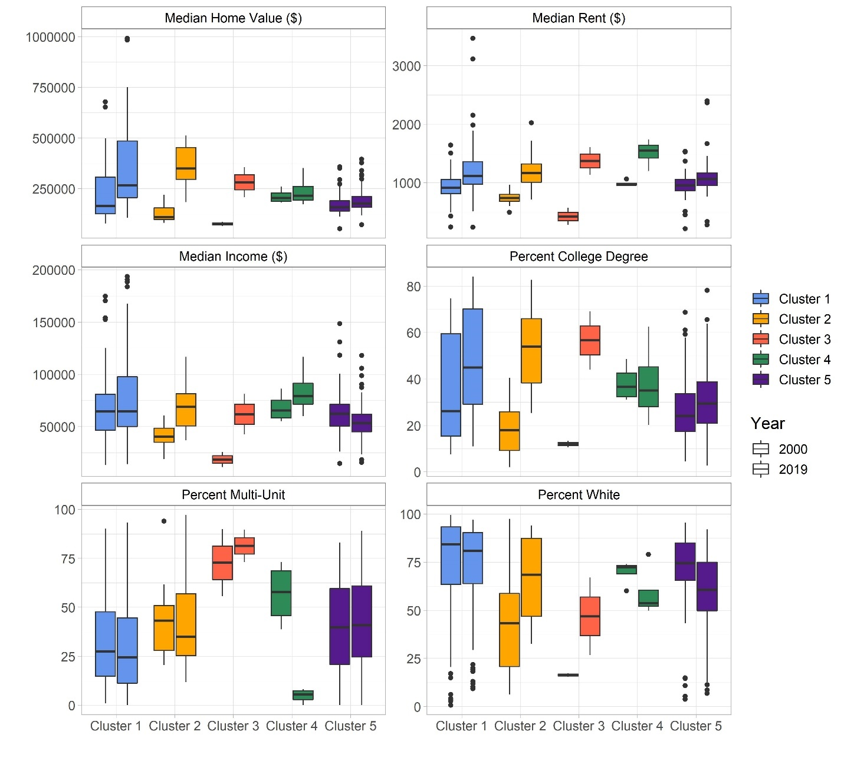

Cluster 1 comprises 59 census tracts. This neighborhood change typology includes some of the wealthiest and whitest more suburban communities. This typology is composed of Davidson County’s most expensive home and rent census tracts as well as the highest income, college, and white census tracts in both 2000 and 2019. This neighborhood typology began the millennium above average the measured socioeconomic variables and modestly increased this status over nearly two decades. This cluster saw little change in income, white, and college-educated residents relative to other clusters suggesting it is stable middle and upper class suburbs.

Table 4. Cluster 1 summary statistics

|  |  |  |  |  |  |  |  |
| --- | --- | --- | --- | --- | --- | --- | --- |
| **Cluster 1 (n=59)** | **2000** | **2019** |  | **Percent Change** | | | |
| *Median* | *Median* |  | *Mean* | *Min.* | *Median* | *Max.* |
|  |  |  |  |  |  |  |  |
| Median Home Value | $165,246 | $268,000 |  | +59% | +8% | +55% | +159% |
| Median Rent Value | $915 | $1,122 |  | +30% | -25% | +22% | +226% |
| Median Household Income | $64,530 | $64,688 |  | +13% | -26% | +8% | +86% |
| Percent College Degree | 26% | 45% |  | +13% | -3% | +12% | +33% |
| Percent Multi-Unit Housing | 28% | 25% |  | -3% | -24% | -2% | +16% |
| Percent White | 84% | 81% |  | +0% | -14% | -1% | +25% |

Cluster 2 exhibits distinguishable patterns of late-stage gentrification and signals of residential displacement captured by socioeconomic and race variables. This typology is composed of 17 Census tracts, all spatially clustered from downtown Nashville. It is differentiated by the second-largest average increases in home value (+194%), college (+35%), income (+63%), and white proportions (+27%) across all tracts.

Table 5. Cluster 2 summary statistics

|  |  |  |  |  |  |  |  |
| --- | --- | --- | --- | --- | --- | --- | --- |
| **Cluster 2 (n=17)** | **2000** | **2019** |  | **Percent Change** | | | |
| *Median* | *Median* |  | *Mean* | *Min.* | *Median* | *Max.* |
|  |  |  |  |  |  |  |  |
| Median Home Value | $111,163 | $350,500 |  | +194% | +59% | +204% | +291% |
| Median Rent Value | $741 | $1,169 |  | +63% | +23% | +61% | +128% |
| Median Household Income | $40,599 | $68,889 |  | +63% | +13% | +61% | +107% |
| Percent College Degree | 18% | 54% |  | +35% | +20% | +33% | +55% |
| Percent Multi-Unit Housing | 43% | 35% |  | -2% | -21% | -2% | +12% |
| Percent White | 43% | 68% |  | +22% | -6% | +23% | +60% |

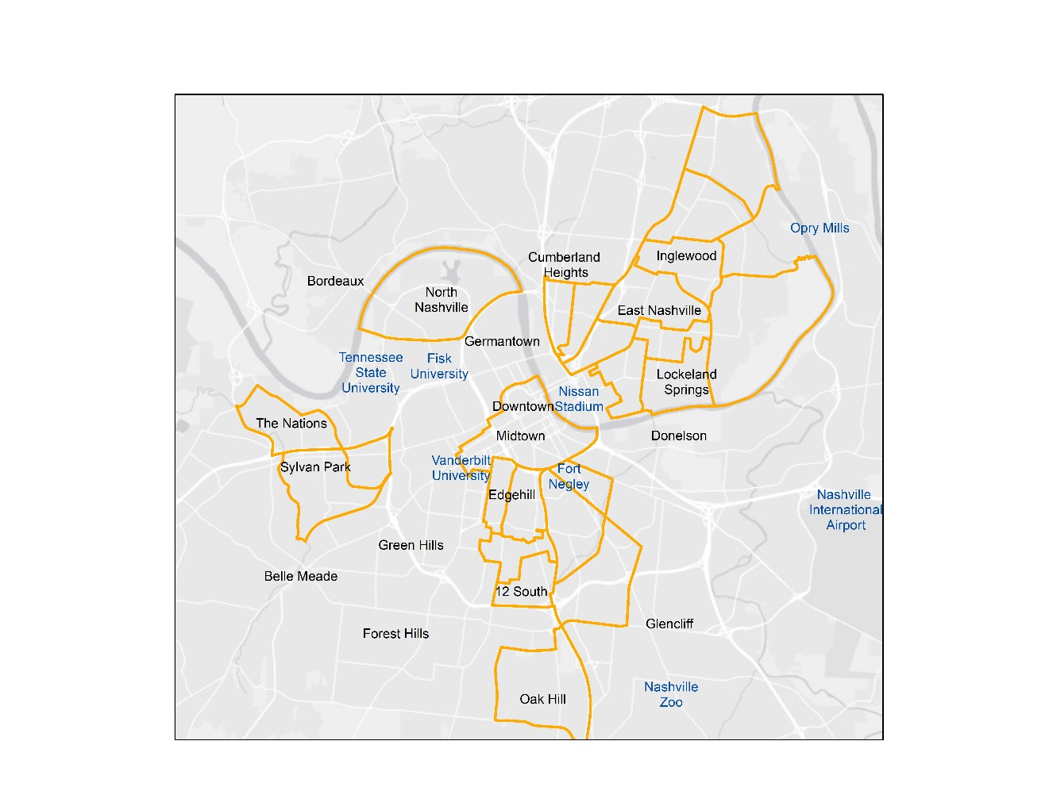

Figure 6. Cluster 2 zoomed locations

Cluster 3 contains two central city census tracts (Figure 8) which have experienced the largest socioeconomic, racial, and built environment changes across all Davidson County clusters. This cluster saw extreme increases in each of the six measured socioeconomic variables: home (+262%), rent (+244%), education (+45%), income (+244%), white (+31%), and multi-unit (+9%). In addition to the intense socioeconomic changes, the increase to multi-unit dwellings (+9%) indicates long-term changes to housing options. This typology parallels many of the change characteristics of Cluster 2, but at more extreme change rates and more socioeconomically vulnerable to start the millennium. is considered an extreme example of gentrification, termed “Hyper-gentrification.” Cluster 3 is differentiated from Cluster 2 by a high percentage of multi-unit dwellings both in absolute terms during 2000 and 2019, as well as relative change, posting a 9% increase.

Table 6. Cluster 3 summary statistics

|  |  |  |  |  |  |  |  |
| --- | --- | --- | --- | --- | --- | --- | --- |
| **Cluster 3 (n=2)** | **2000** | **2019** |  | **Percent Change** | | | |
| *Median* | *Median* |  | *Mean* | *Min.* | *Median* | *Max.* |
|  |  |  |  |  |  |  |  |
| Median Home Value | $76,719 | $283,050 |  | +262% | +215% | +262% | +310% |
| Median Rent Value | $427 | $1,376 |  | +244% | +182% | +244% | +306% |
| Median Household Income | $18,599 | $61,948 |  | +244% | +216% | +244% | +272% |
| Percent College Degree | 12% | 57% |  | +45% | +31% | +45% | +59% |
| Percent Multi-Unit Housing | 73% | 81% |  | +9% | 0% | +9% | +18% |
| Percent White | 16% | 47% |  | +31% | +11% | +31% | +50% |

Figure 8. Cluster 3 inner-city census tract locations

Cluster 4 contains four suburban census tracts in the southeastern-most portion of Davidson County. This cluster is distinguished by the highest median starting home values in 2000, but with relatively moderate home value increases (+11%) and large rent increases (+53%), possibly related with the largest decrease in multi-unit housing (-52%). Cluster 4 saw racial diversification over the period, with the second-largest decrease in percentage of white residents (-11%) as well as a 22% increase in household income.

Table 7. Cluster 4 summary statistics

|  |  |  |  |  |  |  |  |
| --- | --- | --- | --- | --- | --- | --- | --- |
| **Cluster 4 (n=4)** | **2000** | **2019** |  | **Percent Change** | | | |
| *Median* | *Median* |  | *Mean* | *Min.* | *Median* | *Max.* |
|  |  |  |  |  |  |  |  |
| Median Home Value | $204,367 | $216,000 |  | +11% | -8% | +8% | +36% |
| Median Rent Value | $969 | $1,557 |  | +53% | +25% | +53% | +80% |
| Median Household Income | $65,494 | $79,312 |  | +22% | +6% | +22% | +39% |
| Percent College Degree | 37% | 35% |  | -0% | -11% | -2% | +14% |
| Percent Multi-Unit Housing | 58% | 6% |  | -52% | -66% | -52% | -39% |
| Percent White | 72% | 54% |  | -11% | -19% | -14% | +5% |

Cluster 5 includes 74 suburban census tracts notably concentrated along Nashville’s major northeastern (I-65) and southeastern (I-24) interstates. While home (+14%) and rent (+10%) values increased, they remained well below Davidson County averages (+53% and +29%, respectively). Household incomes (-13%) and proportion of white residents (-12%) both decreased, while multi-unit housing (+3%) increased. These areas represent possible relocation areas for those displaced from gentrifying inner-city areas.

Table 8. Cluster 5 summary statistics

|  |  |  |  |  |  |  |  |
| --- | --- | --- | --- | --- | --- | --- | --- |
| **Cluster 5 (n=74)** | **2000** | **2019** |  | **Percent Change** | | | |
| *Median* | *Median* |  | *Mean* | *Min.* | *Median* | *Max.* |
|  |  |  |  |  |  |  |  |
| Median Home Value | $158,492 | $178,050 |  | +13% | --23% | +9% | +67% |
| Median Rent Value | $959 | $1,068 |  | +15% | --41% | +11% | +106% |
| Median Household Income | $62,423 | $53,556 |  | --13% | --51% | --12% | +15% |
| Percent College Degree | 24% | 29% |  | +4% | --10% | +4% | +23% |
| Percent Multi-Unit Housing | 40% | 41% |  | +3% | --15% | +1% | +32% |
| Percent White | 75% | 61% |  | --12% | --42% | --11% | +11% |

The spatial patterning of these potential relocation areas away from the inner-city is consistent with residential displacement relocations found in New York City (Wyly et al., 2010). This finding is also in line with previous research that suggests accessibility to labor markets via highways may be a factor in relocation housing preferences (Voith, 1993).

Compared with previous methods to identify gentrification in Davidson County, the clustering results here identified fewer tracts than the Freeman method (37), and more than the O’Regan (8) and McKinish et al. (5) methods[8]. These locations corroborate anecdotal accounts of gentrification within neighborhoods such as Germantown, Edgehill, and East Nashville (Plazas, 2017). It should also be reiterated that these are relative measurements rather than net mobility/displacement measurements, but the patterns in Clusters 2 and 3 are highly suggestive of residential and ethnic displacement. This evidence for this displacement was used to differentiate the process apart from revitalization or incumbent upgrading.

## Spatial Significance

The spatial analysis Nashville neighborhood change typologies rejects a null hypothesis that the spatial distribution of neighborhood change occurs randomly, in an unstructured process. The k-color join count test returns p-values for each typology’s spatial distribution based on the defined neighbor relationship (Table 4). First-order queen’s contiguity resulted in a p-value < .05 for all clusters except for Cluster 4, which appears only in the southeastern-most corner of Davidson County. Cluster 4 tracts are inter-spaced by one non-similar tract and the typology is significant using the second-order queen’s contiguity relationship. Together, these results provide evidence suggesting a non-random neighborhood shaping process and also imply that signals of investment and disinvestment in one area are likely not independent of neighboring census tracts. This may be explained, in part, to the nature of census tract geography, which often follow non-physical barriers and often don’t delineate neighborhood designations or development patterns.

Table 9. First and second order queen’s case contiguity join count results.

|  |  |  |
| --- | --- | --- |
| **Cluster** | **First Order  p-value** | **Second Order  p-value** |
| Cluster 1 | 0.005 | 0.064 |
| Cluster 2 | <0.001 | <.001 |
| Cluster 3 | 0.019 | 0.058 |
| Cluster 4 | 0.601 | 0.006 |
| Cluster 5 | <0.001 | <0.001 |

A mutually inclusive explanation adheres to Waldo Tobler’s first law of geography- “*everything is related to everything else, but near things are more related than distant things.*” In the context of neighborhood change, this explanation intuitively supposes that change in one area can meaningfully influence the perception of nearby areas. When this phenomenon is extrapolated across two decades and a diverse set of agents with competing interests, we find robust evidence on a system-level that neighborhoods near each other change more similarly than neighborhoods more distant from one another. Such spatial inter-dependencies are observed in other cities such as Chicago, Detroit, and Phoenix (Ling and Delmelle, 2016).

The spatial clustering of Nashville gentrification typologies provides further evidence of a selective, structured process rather than a sporadic one as postulated by early gentrification research. This observation compels forward-looking research that may anticipate and mitigate the negative externalities of gentrification before it takes hold in a neighborhood. Brown-Saracino (2017) describe gentrification as a “contagious” process which metastasizes from nearby gentrifying neighborhoods. Furthermore, the spatial information uncovered here demonstrates the importance of endogenously engineered variables that factor in adjacent census characteristics. This extends the scope of the gentrification process beyond a single census tract, but importantly considers neighboring factors in future risk considerations.

## Sensitivity

Figure 7 shows the mapped results and sensitivity of changing cluster sizes, K. A typology consistent with gentrification is apparent at all cluster sizes, suggesting the process is one of the most dominant and distinguishable patterns of neighborhood change in Nashville. At K=5, a portion of the rural tracts (Cluster 1) are partitioned into a fifth cluster. This additional cluster contains tracts with more moderate property value increases as well as lower relative decreases in non-white populations compared with the remaining gentrifying areas (Cluster 2). This suggests that the selection of K clusters may be relatively insensitive up to four clusters, after which a portion of the gentrified areas more closely align with other areas and their associated change trajectories. The specification of a larger K could allow for differentiation between different types of gentrification (moderate/advanced, early/mature, or displacement/incumbent upgrading).

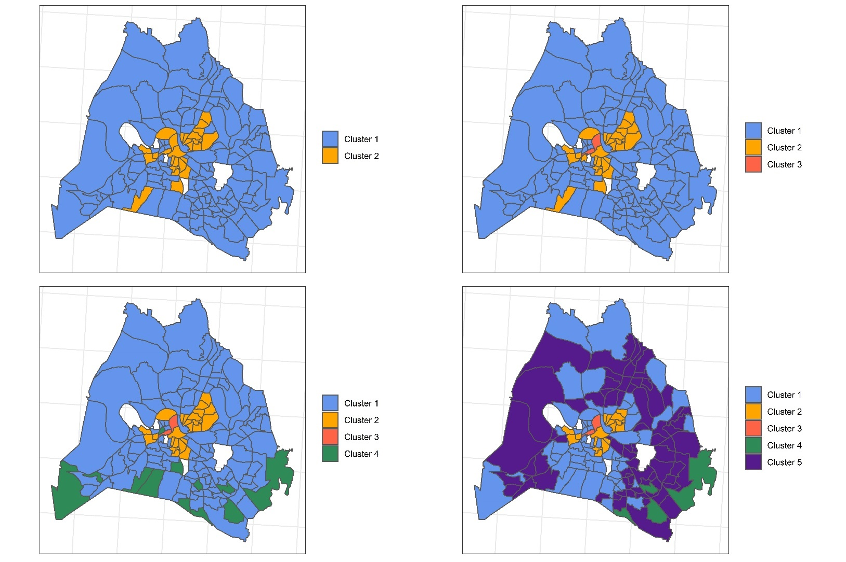

Figure 9. Davidson County K-means clustering sensitivity

# Conclusion

Gentrification is a uniquely dynamic socio-economic force that has resisted the best efforts of scholars to abstract, generalize, and measure. There remains a conspicuous disconnect between the theoretical advancements of gentrification and the practical methods used to identify it in a consistent and precise way. Much of the confusion in gentrification research can be traced back to the process’s usefulness in advancing broader social, political, and economic ideologies. We see as an initial remedy on the research front, the need to mitigate subjectiveness ingrained in the quantitative methods that are foundational to an entire subfield of research on the consequences of gentrification.

Ironically, residents facing the financial and social threats of gentrification do not need a machine learning algorithm to tell them their neighborhood is undergoing gentrification. What is self-evident on the ground-level has proved to be anything but quantitatively for researchers. The pairing of emotionless machine learning methods with a deeply personal experience like gentrification feels contradictory. However, it is precisely because of this dichotomy that we must embrace more objective tools that identify real patterns rather than reproduce our own assumptions and biases. As the conceptual understanding of gentrification has evolved, the techniques used to measure the process should similarly evolve. Researchers have the responsibility to explore less biased alternatives that can capture the multiple dimensions and complexity that the process represents. Consistent, transparent, and contemporary research will go a long way in our efforts to create more socially just and equitable communities.

Future work would benefit from evaluating both the spatial extent and magnitudes of gentrification across different cities. City-specific data sources such as building permits, evictions, code violations, and home appraisal/sales values are largely untapped metrics that can be incorporated into this multi-dimensional framework. Finally, gentrification research may find more success with forward-looking research, mitigative in approach rather than adaptive. Policies to combat gentrification may prove too late once it is observed on the ground. Reactionary policies have been largely inadequate in their attempts to stall the economic and preference-based engines powering gentrification. However, policies that are implemented before gentrification takes a hold of a neighborhood may find more support. For this, predictive machine learning may again offer an opportunity to learn from the common characteristics that gentrified neighborhoods shared in the past and direct resources that build and protect existing residents’ capacity to stay in areas most likely threatened in the future.

To truly advance, we must uncomfortably recognize that our endeavors to classify, categorize, generalize, or otherwise distinguish gentrification apart from other types of neighborhood change are deeply human classification exercises that are shaped by our own bias and subjectivity. The radical diversity of gentrification research methods aligns closer with individual experiences, personal heuristics, politics, and expectations than objective science. Urban change research is inextricably responsible for crystallizing public opinion and influencing policy actions on gentrification. The wealth of contradictory evidence, largely driven by inconsistent methodologies, has permitted both supporters and opponents of gentrification a means to entrench their views on the subject. This research field stands to benefit from the emotionless 21st century tools that reveal emergent patterns within the data itself rather than conforming to a preordained framework.

1. Lees effectively describes the concept of a bias-variance tradeoff seen in applied statistics or machine learning. Low bias equals broad generalizations while low variance miscategorize the current problem. The ideal model has low bias to accurately simulate the true relationship and low variability that produces consistent predictions across different datasets.
2. McKinnish et al.’s national comparison identifies gentrifying census tracts in 91% of Consolidated Metropolitan Statistical Areas between 1990 and 2000.
3. Who copied these methods Lester and Hartley (2013) use the Freeman’s definition to herald the local employment benefits in gentrifying neighborhoods. Chapple, 2009
4. Freeman repeats his analysis using an equally arbitrary (40th percentile) threshold criteria before asserting that the choice did not impact his conclusions.
5. Gentrification disproportionally threatens renters when compared to homeowners. Despite correlation between these metrics, both rent and home values are included to capture this effect.
6. We initialized the algorithm by selecting the optimal starting centroids out of 50 random permutations, and report little variability within the initialization selection.
7. Queen’s case is the preferred contiguity for irregularly shaped aerial units like Census tracts (Anselin, 2018).
8. Measured from 2000 – 2010.